Name :B.Dega Simha Reddy

Reg no : 192111123

Course Code : CSA0726

**COMPUTER NETWORKS**

1. Simulating X, Y, Z Company Network Design

step1:-first take core router

step2:-link that router with distributers and switchs and connect with pc’s and printer and server

step3:-connect that connect with pc’s and printer and server to the switchs

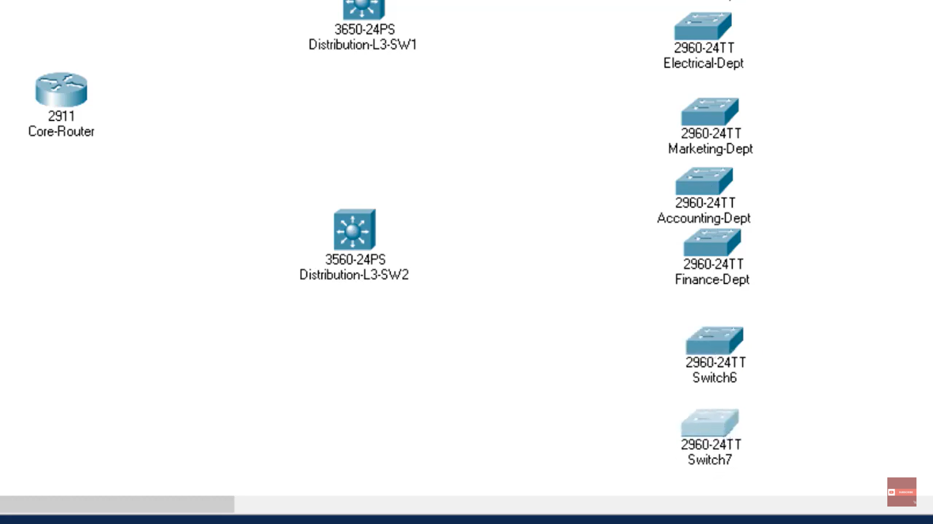

step4:- after connection connect with pc’s and printer and server with connection of tablet Check the connection with the appliances of the server

step5:- if command send correctly you got successfull other wise recheck the connections

Step6:- then the Simulating X, Y, Z Company Network Design in packet tracer was simulated by using the switchs , routers , pc’s , servers it was simulated

